1. A ‘Travision Trips’ is an e-travel portal to help travelers/tourist a complete travel solution. The company’s vision is to provides its customers a platform where they can plan their vacation themselves. It provides its customers a to craft their vacations as per their budget and choices. Their services includes lodging, transportation (that includes car rental services, bus trips, rail, air) and leisure activities. To get the users must logged in with their account and once users are logged in, they provide their choices as well as the budget. The application gives suggest the possible solutions as per choices provided by the user. To provide these services ‘Travision Trips’ has developed an E-commerce solution ‘Travision Easy Access’, that provide users an access to all the services via their software. ‘Travision Easy Access’ have direct accesses to the databases of all the service providers whose services can be accessed via “Travision Trips’ web portal. Your task is to draw and labeled an n-tier architecture of ‘Travision Trips’. [5Marks]

2) Structure the airline travel system by supposing that you travel from Toronto to London by air.

a. Identify and discuss the series of actions you take in a five layered architecture from the start of your journey at Toronto and then five layered actions at the arrival on destination London. [5 Marks]

b. Support your answer by drawing a layered architecture at the starting point of the journey and the destination. Your answer must identify and discuss the action identified both at Toronto and London. [5 Marks]

* A) The steps or series of actions required in a five-layered architecture when moving from Toronto to London are as follows:

1. Layer 5 (Application Layer): This layer acts as a ticketing layer where I need to enter the airport and have to purchase tickets from the airline counter in order to fly.
2. Layer 4 (Transport Layer): This layer acts as luggage checking layer where the luggage or bags are being loaded and went for checking process where I need to make sure about the weighting criteria that is being allowed by the airlines
3. Layer 3 (Network Layer): This layer acts as an entry layer that helps me in boarding the plane along with the loaded luggage.
4. Layer 4 (Datalink Layer): This layer acts as a take-off layer where I will be allowed to have my seat according to my seat number in the plane and gradually the plane will take-off from the Toronto international airport.
5. Layer 5 (Physical Layer): This layer acts as a linking layer as it links Toronto airport with the London airport by following and implementing a proper set of route.

The set of actions required in a five-layered architecture when arriving in London airport are as follows:

1. Layer 1(Physical Layer): This layer is implemented as a linking layer that links routes of London and Toronto airports.
2. Layer 2(Datalink Layer): This layer acts as an arrival or landing layer which describes the landing process of the plane at the airport.
3. Layer 3(Network Layer): This layer will act as a plane exit layer where I will be getting off from the plane and further proceed with the check-in process.
4. Layer 4(Transport Layer): This layer acts as a luggage layer where I would claim my luggage from the luggage area and proceed on exiting the London airport.
5. Layer 5(Application Layer): This layer acts as the main exit layer which shows about reaching my selected or desired location in London.

* B) The figure of layered architecture from the starting point of the journey to the destination is described below:

* The actions identified both at Toronto and London airport are:

Here, the above figure describes the actions of the airline features as we can see that the same process was happening at both the Toronto as well as at the London airport and one thing was different and that was the functioning of the layers at the journey point and the destination point. Moreover, each and every layer showcases some functionality, and it is implemented in the layered architecture. Also, at the main ticketing layer, my ticket checkup is successfully done both at Toronto and London airport, at the luggage layer the bags were checked and loaded whereas on the other hand the bags were claimed successfully so this layer was also successfully accomplished and just like that runway-to-runway transfer of person’s items as well as my bags were also done perfectly so this way each layer performs a certain kind of action in that specific layer and performs the task in a better way.

3) Assume that you are accessing a Seneca website from your home computer (desktop/laptop/tablet).

a. Identify and discuss the method used at your home to access the Internet and then connection with the Seneca web server. [5 Marks]

b. Sketch/draw a network connection from your device to the Seneca web server. [5 Marks]

* A) Accessing a Seneca website from my home laptop:

First of all, a wireless router connection or Wi-Fi links my laptop to the internet. My Laptop connects to the ISP(Internet Service Provider) through my home router and obtains the necessary internet connection by using an IP Address, which is a machine-specific address. After that, in the address bar of my browser, I type the Seneca website address. The browser then searches the DNS(Domain Name System) for the Seneca web server's matching IP address using the domain name which is present or mentioned in the URL and further when the following IP addresses get matched then the browser makes use of a three-way handshake process to build a TCP(Transmission Control Protocol) connection with the Seneca’s web server. As the name suggests that the three-way handshake process consists of three steps where in the first step, the connection between client and server is established, in the second step, the server receives the SYN packet i.e. Synchronize sequence number from the client end while in the third step, the client node receives the SYN/ACK (Acknowledgement Sequence Number) from the server and it responds back with an ACK packet. When the connection is established successfully, the browser then sends an HTTP GET request to Seneca’s web page. After that, when the web server receives the request, it looks for the requested page and, if it is located, delivers it back as a response otherwise it will showcase an error message as of HTTP 404 not found. In addition, the browser also looks for other important elements that complete the webpage scenario so separate requests are issued or more connections are established by the browser for each component of the webpage. Finally, this way after proper stacking of each and every component, a proper Seneca webpage develops and appears on the browser window so basically, this way the connection with the Seneca web server is done as all these processes are very fast.

b)

 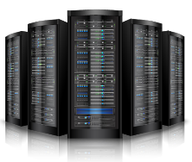 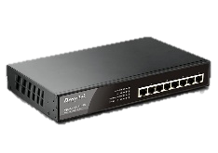

Microsoft Server

Switch

My Laptop

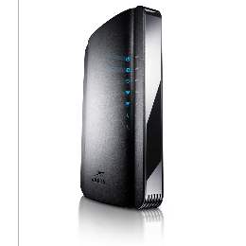 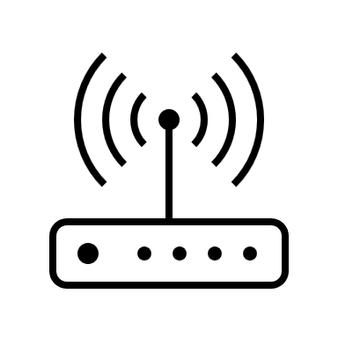

Router

Modem

   

Port Server

Router

Router

Router